Applicants who does not registered with Brunei Identity Cards
Checklist for Overseas Applicants
Section A

- Fill in the form provided. (downloadable at www……com)
- Email application form to application@spa.gov.bn
- Attached related documents in the email. (See section ‘B’)
Section B

Documents required to be attached in the email:

FOR RELEVANT MINISTRY / DEPARTMENT POSTS
- PSC Application Form; downloadable at www…..…com
- Curriculum Vitae
- Basic Degree or Equivalent
- All relevant Graduate Qualifications Certificates and Transcripts; and Professional Membership
- Current and/or previous experience in related job field
- Letters of Service/Proof of Employment

Section C

IMPORTANT REMINDER

Email subject should be in all BLOCK LETTERS and in accordance to below example:
YOUR NAME-MEDICAL OFFICER GRADE II-ADVERTISEMENT NUMBER
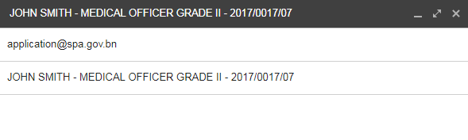

Email content should also include;
- Applicants’ full name and passport number
- Email job application letter (Cover Letter)

Email used for application submission must be active as further communication may be made via the same email address.

All scanned documents must be:
- In colour as per original document
- Saved as PDF format
- Size not more than 2MB
- File name must not contain any symbols such as-!@#$%^&*()?{} & etc
- Must be certified true copy

**Applications that does not follow provided guidelines may be rejected due to incomplete application.

